**WEARABLE BIOSENSORS**

**A Seminar Report**

Seminar Report submitted in partial fulfilment of the requirements for the award of the degree of BCA. in Delhi Technical Campus, Greater Noida under Guru Gobind Singh Indraprastha University, New Delhi

by

Jhanvi Pathak

Enrollement No.: 35318002020

Under the Guidance of

Ms Preeti Pandey

(Associate Professor)

(Department of Computer Science Engineering)



DELHI TECHNICAL CAMPUS,

GREATER NOIDA

2022-23

**CERTIFICATE**

This is to certify that the Seminar entitled WEARABLE BIOSENSORS presented by Jhanvi Pathak bearing Enrolment No. 35318002020 of Delhi Technical Campus, Greater Noida has been completed successfully.

This is in partial fulfilment of the requirements of Bachelor of Computer Application in Delhi Technical Campus, Greater Noida under Guru Gobind Singh Indraprastha University, New Delhi

I wish her success in all future endeavours.

Ms. Preeti Pandey

Associate Professor

Department of Computer Science Engineering

**ACKNOWLEDGEMENT**

I express my sincere gratitude to my Seminar Guide Ms Preeti Pandey, Associate Professor, Computer Science and Engineering Division for his constant support and valuable suggestions without which the successful completion of this seminar would not have been possible.

I express my immense pleasure and thankfulness to all the teachers and staff of the Department of Computer Science and Engineering, Delhi Technical Campus, Greater Noida for their cooperation and support.

Signature of the Student

Name: Jhanvi Pathak

Enrollment No: 35318002020

Semester: 6th

Branch: BCA

Date:

**ABSTRACT**

Wearable biosensors have gained significant attention in recent years due to their potential for continuous health monitoring and personalized healthcare. These sensors are designed to be worn on the body, capturing physiological data in a non-invasive and convenient manner. This seminar report provides an overview of wearable biosensors, their working principles, applications, and future trends. The report also highlights the challenges and limitations associated with wearable biosensors, including accuracy, data privacy, user acceptance, and standardization. It discusses ongoing research efforts to address these challenges and improve the performance and usability of wearable biosensors.

**TABLE OF CONTENTS**

|  |  |
| --- | --- |
| Acknowledgements | 3 |
| Abstract | 4 |
| List of Tables | 6 |
| 1. Introduction    1. DEVELOPMENT OF WEARABLE BIOSENSOR   1.1.1 FINGER WORN BIOSENSORS   1. BASIC PRINCIPLE OF FINGER WORN BIOSENSORS 2. FINGER WORN BIOSENSORS WORKING 3. Block Diagram 4. Application of FINGER WORN BIOSENSORS 5. Advantages 6. Disadvantages   1.1.2 INTELLIGENT GARMENT   1. Requirement 2. Architecture 3. Application of Intelligent garment 4. Advantages 5. Disadvantages | 7  8  8  9  10  11  11  12  12  13  13  14  15  15  16  16 |
| 1. Overviews of wearable biosensors with Literature Reviews | 18 |
| 1. Proposed Work | 19 |
| 1. Tools for wearable Biosensors | 20 |
| 1. Conclusion | 21 |
| 1. Reference | 22 |

**List Of Figure**

|  |  |
| --- | --- |
| 1.1. FINGER WORN BIOSENSORS working | 10 |
| 1.2. Block Diagram | 11 |
| 1.3. Intelligent garment Architecture | 15 |

**List Of Table**

|  |  |
| --- | --- |
| 1.1. Application of Intelligent garment | 14 |
| 2.1. Overviews of wearable biosensors with Literature Reviews | 17 |

1. **INTRODUCTION**

WEARABLE BIOSENSORS=WEARABLE+BIOSENSORS

Wearable biosensors are gaining endless interest nowadays and to

**WEARABLE BIOSENSORS=WEARABLE+BIOSENSORS**

In recent years, advances in sensor technology, wireless communication, and data analysis have resulted in the rise of wearable biosensors as a transformative tool in the realm of healthcare and beyond. These little, non-invasive technologies have the potential to completely transform how we monitor and control our health.

Wearable biosensors are small, portable devices that can be worn on the body to monitor physiological factors such as heart rate, blood pressure, body temperature, and even biochemical markers such as glucose levels. They collect data in real time, allowing for early diagnosis of health conditions, personalised health tracking, and informed decision-making.

Wearable biosensors are gaining popularity due to their ability to improve patient outcomes, increase sports and fitness performance, and empower individuals to adopt a proactive approach to their health. These gadgets can provide useful information about how our bodies react to various activities, stressors, and environmental factors.

The purpose of this seminar report is to investigate the science behind wearable biosensors, their applications in healthcare and fitness, and the difficulties and opportunities connected with their adoption. We will look at how these sensors function, what kinds of data they may collect, and how they can be integrated into our daily lives.

* 1. **DEVELOPMENT OF PORTABLE PHYSIOLOGICAL SENSOR OR WEARABLE BIOSENSOR**

The development of wearable biosensors continues to evolve, driven by advancements in sensor technology, wireless connectivity, power management, data analytics, and interdisciplinary collaboration. These advancements have the potential to transform healthcare by providing continuous, personalized, and real-time monitoring of vital signs and health parameters, enhancing diagnostics, disease management, and overall well-being.

**FINGER WORN BIOSENSORS FINGER WORN BIOSENSORS**

The basic principle of FINGER WORN BIOSENSORSs is to use a sensor to measure the electrical activity of the body. The sensor is typically located on the inside of the ring and is made of a conductive material, such as metal or carbon. When the wearer wears the ring, the sensor measures the electrical activity of the body through the skin.

* The electrical activity of the body can be used to measure a variety of physiological data, such as heart rate, blood pressure, and respiratory rate. The data collected by the FINGER WORN BIOSENSORS can be transmitted to a computer or smartphone for analysis.
* FINGER WORN BIOSENSORSs are a convenient and non-invasive way to collect data about the wearer's health. They are easy to use and easy to use plus pocket friendly. FINGER WORN BIOSENSORSs have the potential to be used to improve the wearer's health by providing feedback on their activity levels, sleep quality, and other health metrics.

**BASIC PRINCIPLE OF FINGER WORN BIOSENSORS**

FINGER WORN BIOSENSORSs work on the basis of capturing and measuring physiological signals or biomarkers from the wearer's finger. While exact implementations may differ, the overall principle entails the components and processes listed below.:

1. Biosensing Element: The FINGER WORN BIOSENSORS incorporates a biosensing element, which can be an optical sensor, an electrode, or another type of sensor depending on the specific application. This element is designed to interact with the wearer's finger and detect relevant physiological signals or biomarkers.

2. Signal Detection: The biosensing element within the FINGER WORN BIOSENSORS detects and measures the desired signals. For example, an optical sensor may emit light into the wearer's finger and measure the reflected or transmitted light to determine blood oxygen levels or pulse rate. Similarly, an electrode-based sensor can detect electrical signals, such as electrocardiogram (ECG) signals, by measuring the electrical activity of the heart.

3. Signal Processing: Once the signals are detected, they are typically processed using signal processing algorithms within the FINGER WORN BIOSENSORS or an external device. Signal processing techniques may include filtering, amplification, noise reduction, and other algorithms to enhance the quality and accuracy of the measured signals.

4. Data Transmission: The processed data is often wirelessly transmitted from the FINGER WORN BIOSENSORS to an external device, such as a smartphone or a dedicated receiver. Wireless communication technologies, such as Bluetooth or Wi-Fi, enable real-time or periodic data transmission, allowing for continuous monitoring and analysis.

5. Data Analysis and Interpretation: The transmitted data is received by an external device, where it can be further analyzed and interpreted. Software applications or algorithms can extract valuable insights from the collected data, providing information about the wearer's health status, activity levels, or specific physiological parameters of interest.

6. User Interaction and Feedback: The FINGER WORN BIOSENSORS may also include user interfaces, such as LED indicators or haptic feedback, to provide immediate feedback to the wearer. This feedback can inform the wearer of their current physiological state or notify them of any abnormal conditions that require attention.

FINGER WORN BIOSENSORSs provide a handy and non-invasive technique of monitoring numerous physiological signals or biomarkers from the finger by utilising these basic principles. Their small and wearable design enables continuous monitoring and has the potential to improve healthcare outcomes and promote proactive wellness management.

**WORKING**

FINGER WORN BIOSENSORSs capture and interpret physiological signals from the wearer's finger through many crucial phases. Here is a high-level overview.

1. Signal Detection: The FINGER WORN BIOSENSORS's activated biosensing element detects important physiological signals or biomarkers from the finger. An optical sensor, for example, may emit light into the skin and measure the reflected or transmitted light to determine blood oxygen levels or pulse rate. By detecting the electrical activity of the heart, electrode-based sensors can detect electrical signals such as ECG signals.
2. Signal Processing: The digital signals are processed within the FINGER WORN BIOSENSORS to improve their quality and retrieve useful information. Filtering, amplification, noise reduction, and feature extraction algorithms are used to modify the collected signals and remove undesired artefacts or noise.
3. Data Transmission: The processed data is wirelessly communicated from the FINGER WORN BIOSENSORS to an external device, such as a smartphone, wristwatch, or specialised receiver. Wireless communication technologies, such as Bluetooth or Wi-Fi, allow for real-time or periodic data transfer, allowing for continuous monitoring and analysis.
4. Data Analysis and Interpretation: The sent data is received by the external device, where specialised software programmes or algorithms analyse and interpret the collected signals. These algorithms may extract relevant insights and parameters from data, delivering information on the wearer's health state, activity levels, or other physiological factors of interest.
5. User Feedback and Display: The analysed findings might be shown on a mobile app or a wearable device. Users may see and analyse the data, obtaining real-time feedback on their physiological status, activity levels, and any anomalies detected by the FINGER WORN BIOSENSORS.

FINGER WORN BIOSENSORSs provide continuous and non-invasive monitoring of numerous physiological signs from the wearer's finger by completing these stages. This enables individualised health tracking, early diagnosis of health concerns, and educated healthcare and wellness management decision-making.

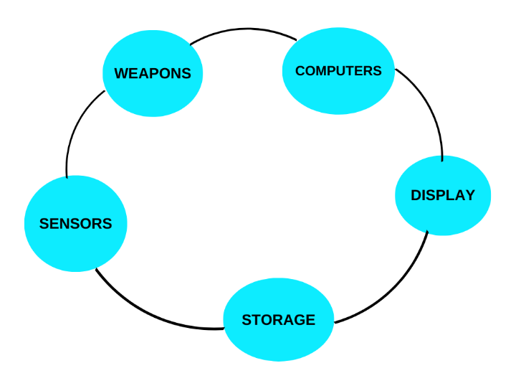

Figure 1.1 Working

**BLOCK DIAGRAM OF FINGER WORN BIOSENSORS**

The power required to operate the light source, photo detector, RF transmitter, analog and digital processing units in a device is supplied by a small cell battery commonly used in wristwatches. The battery has a lifespan of approximately 2 to 3 weeks before needing replacement or recharging.

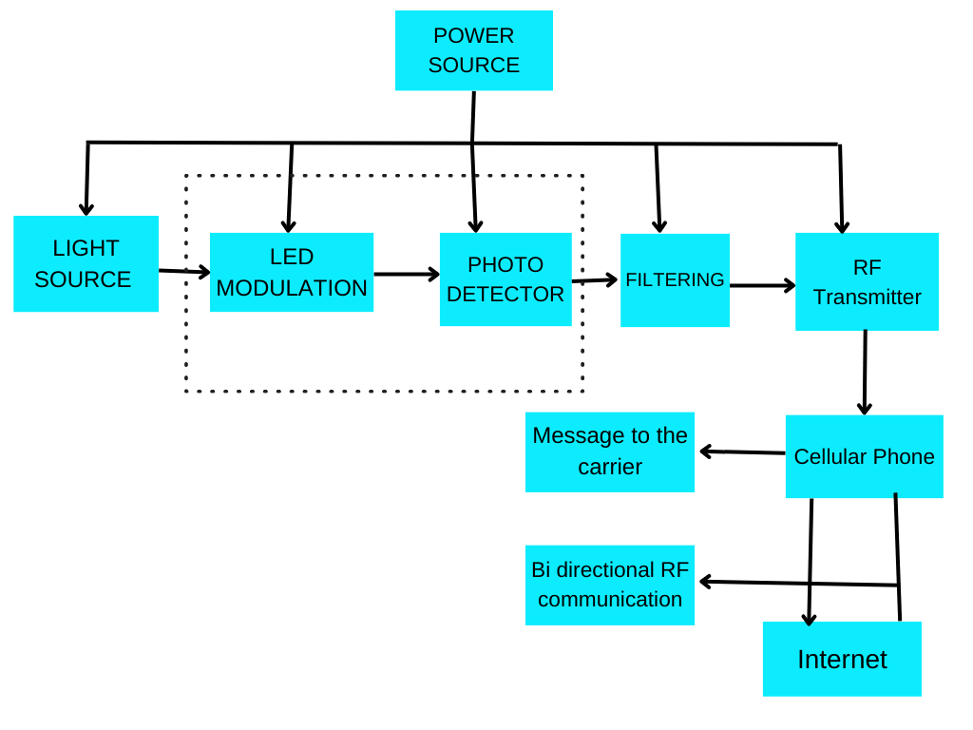

FIGURE 1.2 Block Diagram

**APPLICATIONS OF THE FINGER WORN BIOSENSORS**

* + **Emergency Response Monitoring**

During a disaster, the FINGER WORN BIOSENSORS may be used to monitor the vital signs of emergency responders such as firefighters or search and rescue teams.

* + **Environmental Monitoring**

During a disaster, the FINGER WORN BIOSENSORS may be used to monitor the environment.

* + **Support for Disaster Recovery**

In the aftermath of a disaster, the FINGER WORN BIOSENSORS can help in the recovery process. It can track the health condition of people who are active in relief operations or who live in damaged areas, allowing healthcare experts to monitor their well-being and give targeted support if necessary.

* + **Psychological Well-Being Assessment**

The FINGER WORN BIOSENSORS may also help measure the psychological well-being of those who have been affected by a disaster.

* + **Early Warning Systems**

The FINGER WORN BIOSENSORS, combined with data analysis algorithms, can contribute to the development of early warning systems for catastrophes.

**ADVANTAGES**

* Continuous monitoring.
* Detection of transient phenomena.
* Promote further diagnostic and therapeutic measures.
* Reducing hospitalization fee
* Easy to use

**DISADVANTAGES**

* Initial cost is high.
* Accuracy and Reliability
* Limited Parameter Monitoring

**INTELLIGENT GARMENT**

A Intelligent garment is a type of wearable biosensor that can be used to monitor a person's vital signs, such as heart rate, respiratory rate, and body temperature. Intelligent garment s are made with conductive fabric that is embedded with sensors. The sensors collect data from the body and transmit it to a wireless device, such as a smartphone or tablet. This data can then be used to track a person's health and fitness, or to provide early warning signs of medical problems.

**REQUIREMENTS OF INTELLIGENT GARMENT**

1. Accuracy: The sensors in the shirt should be accurate enough to provide meaningful data.
2. Security: The data collected by the shirt should be secure and protected from unauthorized access.
3. Connectivity: The shirt should be able to connect to a smartphone or other device to transmit data.
4. Battery life: The shirt should have a long battery life so that it can be used for extended periods of time without needing to be recharged.

These requirements are essential in the development of a Intelligent garment that provides accurate and reliable health monitoring while ensuring user comfort, seamless data connectivity, and privacy protection. By meeting these requirements, a Intelligent garment can effectively contribute to personalized health tracking and enhance overall well-being.

**ARCHITECTURE**

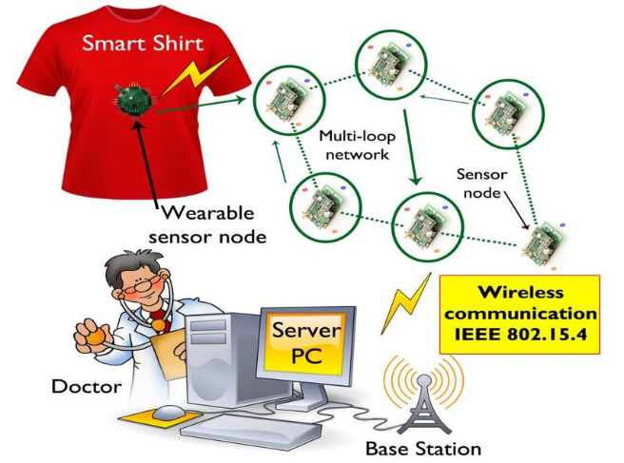

FIGURE 1.3

**The architecture of a Intelligent garment can be divided into three main layers:**

* The sensor layer: The sensor layer is responsible for collecting data from the wearer's body.
* The processing layer: The processing layer is responsible for processing the data collected by the sensors. This data is then used to generate insights about the wearer's health, fitness, and environment.
* The user interface layer: The user interface layer is responsible for displaying the insights generated by the processing layer to the wearer.

**APPLICATIONS OF INTELLIGENT GARMENT**

* Combat casualty care.
* Medical monitoring.
* Sports/ Performance monitoring.
* Space experiments.
* Mission critical/ hazardous application.
* Fire- fighting.
* Wearable mobile information infrastructure.
* The table also shows the application type and the target population that can utilize the technology

|  |  |  |
| --- | --- | --- |
| **Application** | **Application Type** | **Target Population** |
| Fitness Monitoring | Personal Health | Fitness enthusiasts, athletes |
| Health Tracking | Personal Health | General population, individuals |
| Elderly Care | Healthcare | Chronically ill patients |
| Remote Patient Monitoring | Healthcare | Elderly individuals |
| Mental Health Monitoring | Healthcare | Mental health patients |
| Stress Management | Personal Health | Individuals |
| Military Applications | Defense | Military personnel |

TABLE 1.1 Application of Intelligent garment

Summarizes the broad range of application of the Intelligent garment technology. The table also shows the application type and the target population that can utilize the technology.

Overall, Intelligent garment s have the potential to improve the lives of people in a variety of ways. They can help to improve health, fitness, safety, productivity, comfort, and style. As the technology continues to develop, Intelligent garment s are likely to become even more widespread and useful.

**ADVANTAGES OF THE INTELLIGENT GARMENT**

* Continuous Health Monitoring:
* Personalized Health Insights
* Personalized Health Insights

**DISADVANTAGES OF THE INTELLIGENT GARMENT**

* Limited Accuracy
* Skin Irritation:
* Complexity and Maintenance:
* Complexity and Maintenance

1. **Overviews of wearable biosensors with Literature Reviews**

Wearable biosensors are still in their early stages of development, but they have the potential to revolutionize healthcare. By providing continuous monitoring of patients' health, wearable biosensors can help to improve early detection of diseases and prevent serious health complications.

|  |  |  |
| --- | --- | --- |
| TOPIC | YEAR | THEORY |
| Biosignal Monitoring with Wearable Biosensors | Arora, A., & Rani, R. (2020). | Discusses the advancements in wearable biosensors for healthcare monitoring, focusing on biosignal measurements like heart rate, electrocardiogram (ECG), blood pressure, and respiratory rate. |
| Wearable Biosensors for Remote Patient Monitoring: | Coe, T. M., et al. (2018). | Explores the use of wearable biosensors for remote patient monitoring in chronic disease management, discussing the potential benefits, challenges, and future directions. |
| Wearable Biosensors for Fitness and Sports: | Capela, N. A., et al. (2017). | Provides a practical guide on the use of wearable biosensors in sports and fitness applications, discussing their potential for performance monitoring, injury prevention, and training optimization. |
| Introduction to Wearable Biosensors | Gao, W., et al. (2016). | Wearable bio-sensors: from healthcare to human–computer interaction. |
| Sensor Technologies for Wearable Biosensors | Bandodkar, A. J., & Wang, J. (2014). | Reviews various non-invasive sensor technologies, such as electrochemical sensors, used in wearable biosensors, discussing their principles, materials, and applications. |

TABLE 2.1

1. **PROPOSED WORK**

* Develop a wearable biosensor that can measure blood glucose levels: This would be a valuable tool for people with diabetes, as it would allow them to monitor their Individuals can measure their sugar levels without the requirement of finger pricking, enabling non-invasive methods of glucose monitoring.
* Develop a wearable biosensor that can measure heart rate and respiratory rate: This would be a valuable tool for athletes and people who are concerned about their health, as it would allow them to track their fitness levels and identify any potential health problems.
* Develop a wearable biosensor that can detect early signs of disease: This would be a valuable tool for doctors, as it would allow them to diagnose diseases earlier and provide treatment sooner.

These are just a few examples of proposed work for wearable biosensors. As the technology continues to develop, we can expect to see even more innovative and life-changing applications for wearable biosensors.

1. **TOOLS FOR WEARBLE BIOSENSORS**
2. Sensors: The first step in developing a wearable biosensor is to select the appropriate sensors. There are a variety of sensors available, each with its own advantages and disadvantages. Some of the most common sensors used in wearable biosensors include:

* Electrocardiogram (ECG) sensors
* Accelerometers
* Gyroscope
* Microphone
* Ambient light sensors

1. Microcontrollers: Microcontrollers are used to process the data collected by the sensors.
2. Wireless communication modules: Wireless communication modules are used to transmit the data collected by the sensors to a computer or smartphone
3. Battery: Wearable biosensors typically require a battery to power the sensors, microcontroller, and wireless communication module.
4. Display: A display can be used to show the wearer the data collected by the sensors.
5. **CONCLUSION**

Wearable biosensors are a promising new technology with the potential to revolutionize healthcare. They can be used to monitor a wide range of physiological signals, including heart rate, blood pressure, blood glucose levels, and body temperature. This information can be used to track health, diagnose disease, and provide early intervention. This paper discussed the detail view of the application we human used in our daily day to day life. This is the detailed overview of the various applications of wearable biosensors wearable biosensors, including FINGER WORN BIOSENSORSs, Intelligent garment s, stress recognition, and preventing road accidents. The paper also discusses some of the challenges that need to be addressed before wearable biosensors can be widely used. Despite the challenges, the potential benefits of wearable biosensors are significant. They could be used to improve the quality of life for millions of people by helping to prevent disease, diagnose health problems early, and provide personalized treatment plans. Wearable biosensors could also lead to a reduction in healthcare costs by making it easier for people to manage their own health. The Intelligent garment also has a great impact as it leads to the leading in quality of life thereby reducing the healthcare costs and lastly realizing the future healthcare systems. As the technology continues to develop, wearable biosensors are likely to become even more widely used and more effective in monitoring health and preventing disease. So, we can conclude that wearable sensors have a great impact on the future care

.

**REFERENCES**

[1] Asada, H.H., et al., Mobile monitoring with wearable photo plethysmographic Biosensors. Engineering in Medicine and Biology Magazine

[2] Handbook of biomedical instrumentation, Khandpur, pp-138,233,238

[3] H.Harry Asada, “Mobile monitoring with wearable ppg sensors”,IEEE engineering in medicine and biology magazine,vol 22, pp- 28-39 may/june 2003.

[4] F. Lamberti, C. Luni, A. Zambon, P. Andrea Serra, M. Giomo and N. Elvassore, Biomicrofluidics, 2012, 6, 024114.

[5] A Review on Wearable Biosensors for Healthcare Applications by N.R. Pal, S.K. Saha, and S.K. Chaudhuri, published in the journal IEEE Sensors Journal in 2016.

[6] A. J. Bandodkar, C. S. López, A. M. V. Mohan, L. Yin, R. Kumar and J. Wang, Sci. Adv., 2016, 2, e1601465.

[7] Wearable Biosensors: A Review by A.K. Agrawal, S.K. Jain, and A.K. Saxena, published in the journal Sensors in 2016.

[8]https://www.linkedin.com/pulse/biosensors-market-applications-future prospects-prashant-virkhede/

[9] https://www.ncbi.nlm.nih.gov/pmc/articles/PMC7867046/

[10] Wearable Biosensors for Environmental Monitoring by S.A.R. Khan, S.A. Khan, and M.A. Khan, published in the journal Sensors in 2019.

PLAGRISM REPORT

